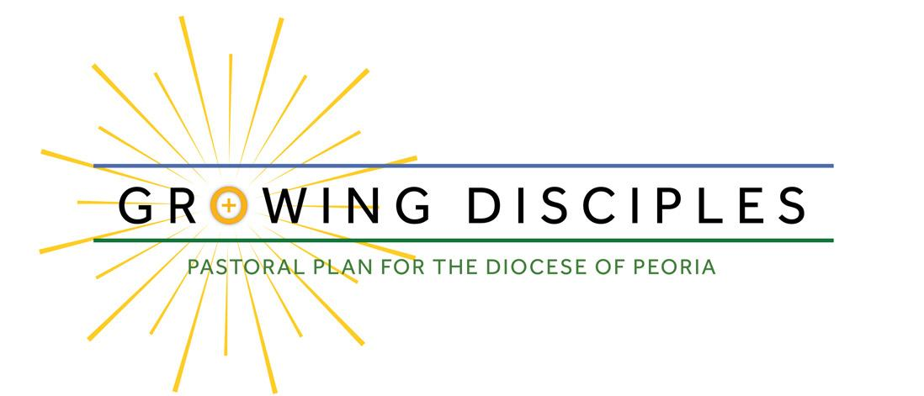
We want to provide you an update regarding Bishop Tylka’s discernment process as part of the Growing Disciples initiative, the multi-year pastoral planning process for the Catholic Diocese of Peoria to renew discipleship and enhance relationships with Jesus Christ in every corner of our region. Bishop Tylka is reading, listening to and praying about all the feedback he is receiving. In the meantime, we want to share with you how he plans to announce his decisions.
On the weekend of May 18 and 19 (Pentecost weekend), each pastor will read a letter from the Bishop at every weekend Mass. The letter will include information specific to each parish and will be shared at all the Masses that weekend.
Between 5 pm and 6 pm on Saturday, May 18, the Diocese will be making the information public regarding all parish changes and priest announcements on its website (growingdisciplescdop.org). That website will also include a glossary of terms, a section of Frequently Asked Questions and a personal message from the Bishop. The website also currently includes materials to help guide you in praying a Novena before the announcement Pentecost weekend. Please join us in praying this Novena for the nine days leading up to Pentecost for the people of the diocese of Peoria. We will begin together May 10. Through these prayers, we will reflect on our history and legacy in the region. Through the outpouring of the Holy Spirit at Pentecost, the faithful will be empowered to go make disciples in our new, mission-driven, sustainable structure of parishes.

